## **Introduction to Natural Language Processing (NLP)**

**1. What is NLP?**

* **Definition**: Natural Language Processing (NLP) is a field that sits at the intersection of linguistics, computer science, and artificial intelligence. Its core concern is the interactions between computers and human language.
* **Goal**: The primary objective of NLP is to **program computers to process and analyse large amounts of natural language data**. Beyond just processing, the ultimate aim is for machines to not only *understand* natural language but also to *communicate* using it, both comprehending what humans say and responding in natural language.
* **Evolution**: While work on NLP began around 50 years ago, it has experienced **significant growth in the last decade**, particularly since the advent of deep learning.

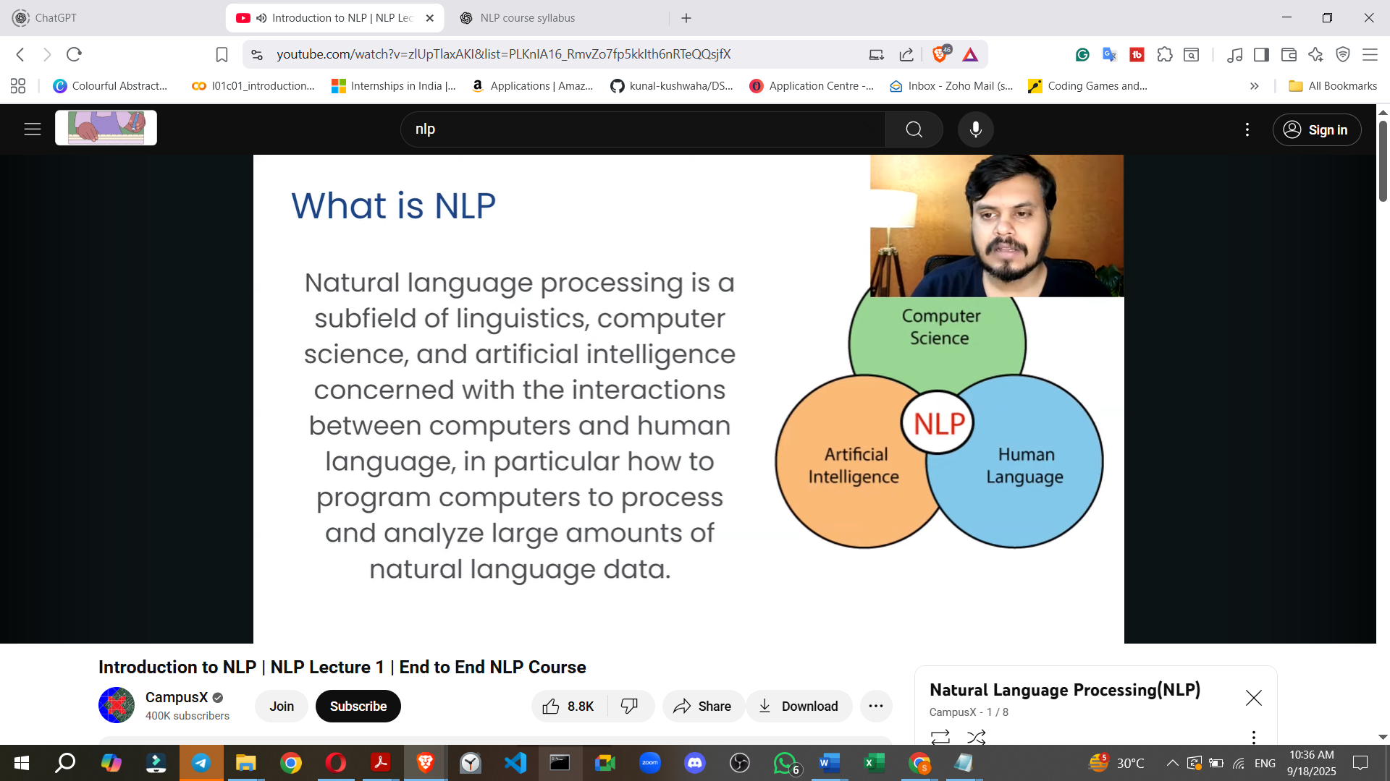

**2. Why is NLP Needed?**

* **Understanding Natural Language**:
  + **Definition**: Natural language (or ordinary language) refers to any language that has evolved naturally in humans through use and repetition, without conscious planning or premeditation. Examples include speech and sign language.

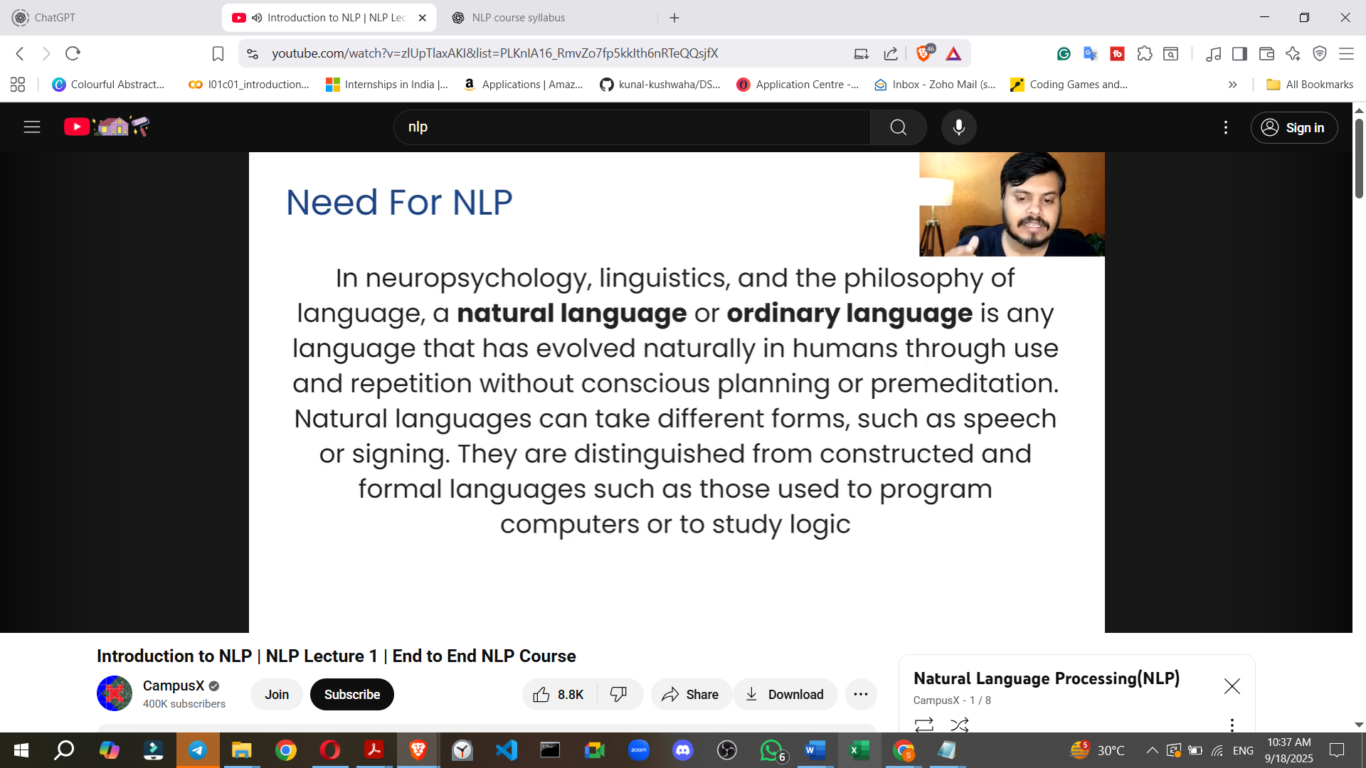

* + **Distinction**: Natural languages are distinct from constructed or formal languages, such as programming languages or logic systems.
* **Human Progress and Communication**:
  + Human history shows that **communication and language have been fundamental drivers of growth and evolution**, enabling humans to share ideas and pass knowledge across generations.
  + The **advent of machines** (e.g., Industrial Revolution) and later the internet further accelerated human progress.
* **The Next Frontier: Human-Machine Interaction**:
  + The next major leap in human evolution is anticipated when humans can **interact with machines as seamlessly as they interact with other humans**.
  + Currently, interacting with machines often requires specialised knowledge (e.g., programming) or specific physical actions (e.g., touch interfaces on smartphones).
  + **Impact**: Enabling natural conversation with machines would dramatically accelerate human progress, making complex technologies accessible to everyone (e.g., an elderly person asking an **ATM** how to operate).
  + **Current Examples**: Early examples like Google Now, Siri, and Cortana illustrate the move towards natural language interaction with machines. NLP is considered **highly important** by major companies, who are investing heavily to lead in this space.

## **NLP Applications**

**A. Real-World Applications**

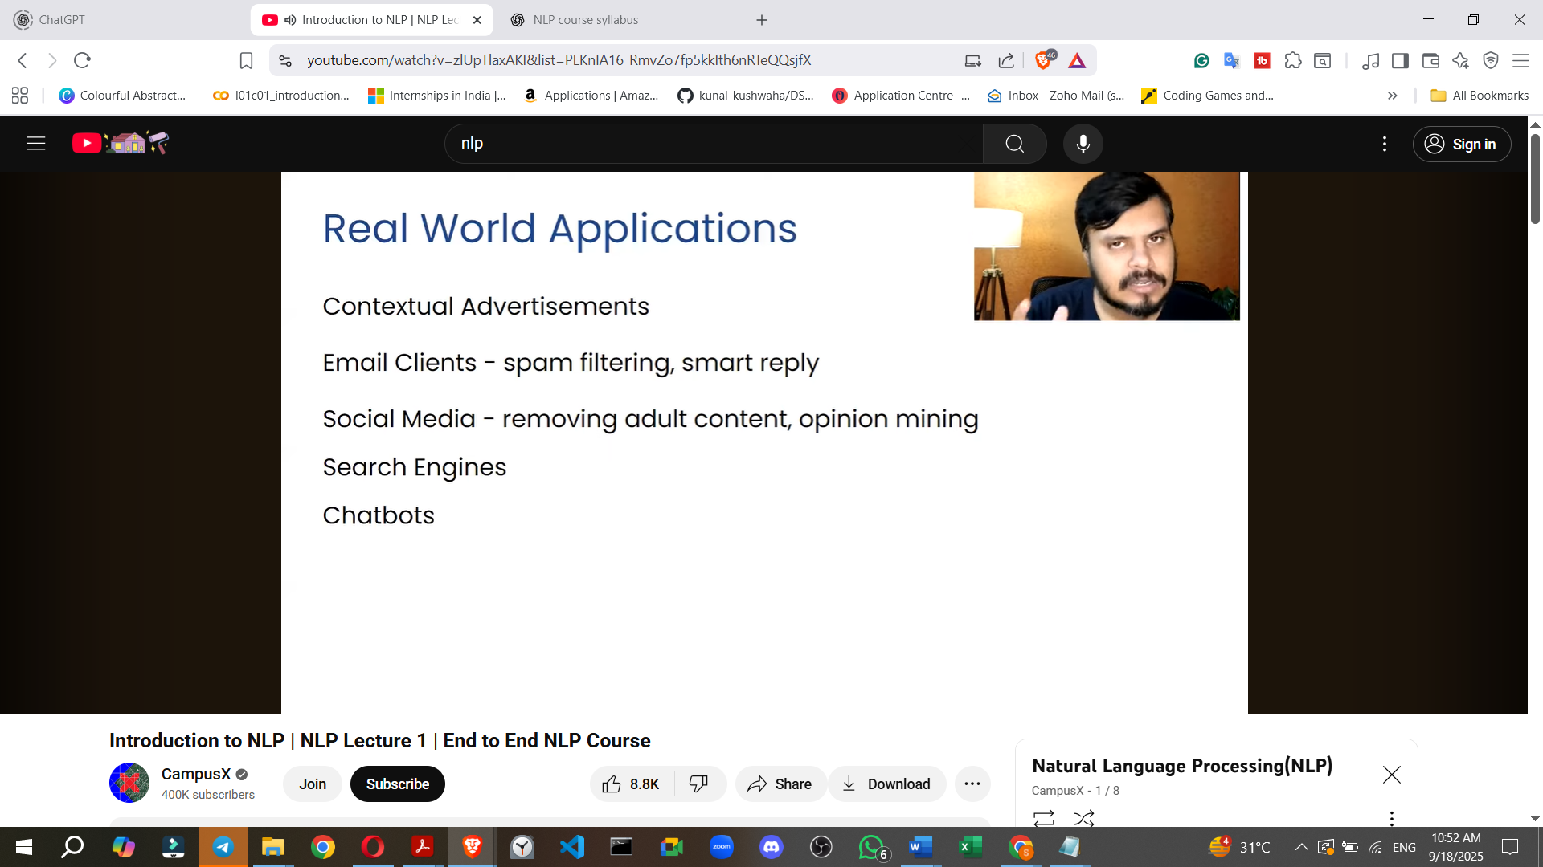

* **Contextual Advertisement**: Companies analyse user profiles, posts, and comments on platforms like Facebook and Instagram to understand interests and display highly targeted advertisements. This can extend to tracking conversations on messaging apps or even spoken words near a device.
* **Email Filtering**: Services like Gmail use NLP to identify and automatically move spam emails to a designated folder, separating them from normal correspondence.
* **Smart Replies**: Email platforms offer quick reply suggestions based on the content of an incoming email, saving users time.
* **Social Media Monitoring**: NLP helps social media platforms:
  + **Remove Adult Content**: Filter out content deemed inappropriate for general consumption.
  + **Block Hate Speech**: Identify and block discriminatory or inflammatory language.
  + **Opinion Mining (Sentiment Analysis)**: Extract public sentiment about specific topics or products by analysing large volumes of user-generated content (e.g., Twitter during elections to predict outcomes).
* **Search Engines (e.g., Google)**: NLP has enabled search engines to evolve significantly, providing direct answers to general knowledge questions (e.g., "What is the capital of Sri Lanka?") without requiring users to navigate websites. The entire functionality of modern search engines heavily relies on NLP.
* **Chatbots**: Used in customer service, chatbots interact with customers, attempting to resolve problems at an initial level before escalating to human agents if necessary. These chatbots mimic human conversation.

**B. Common NLP Tasks for Engineers** For an NLP engineer, these are common tasks used to build applications:

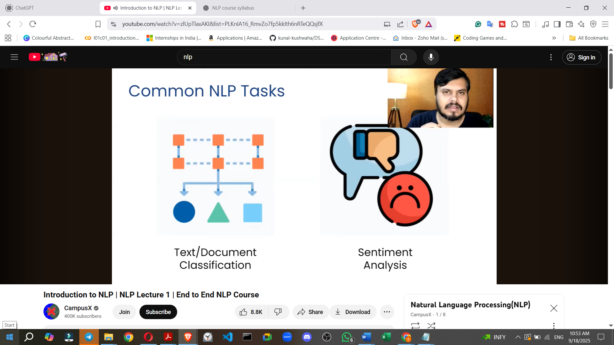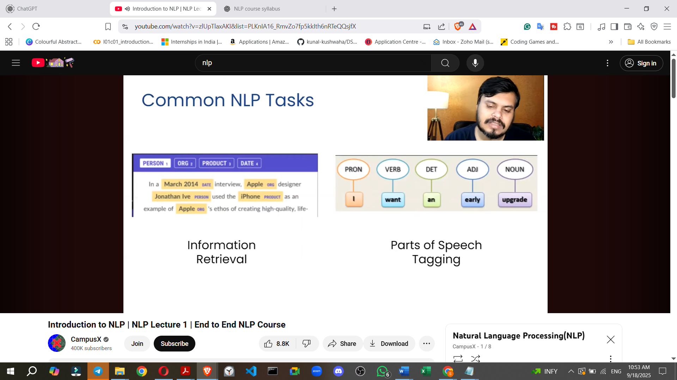

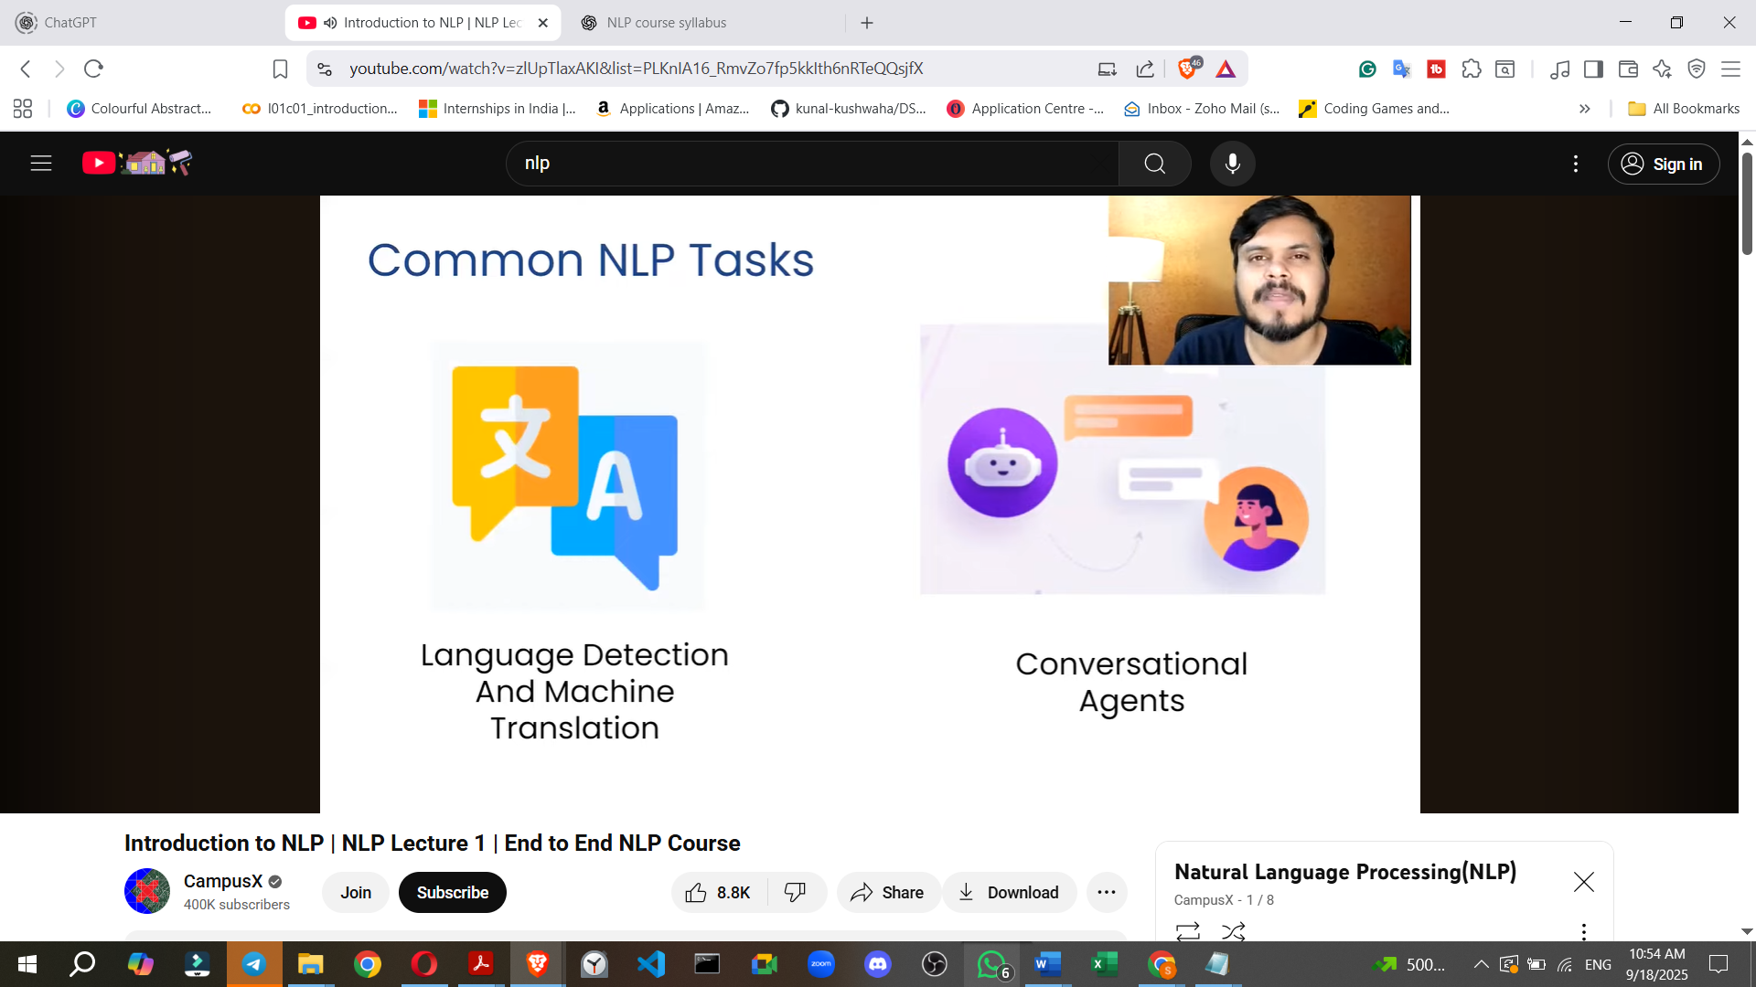

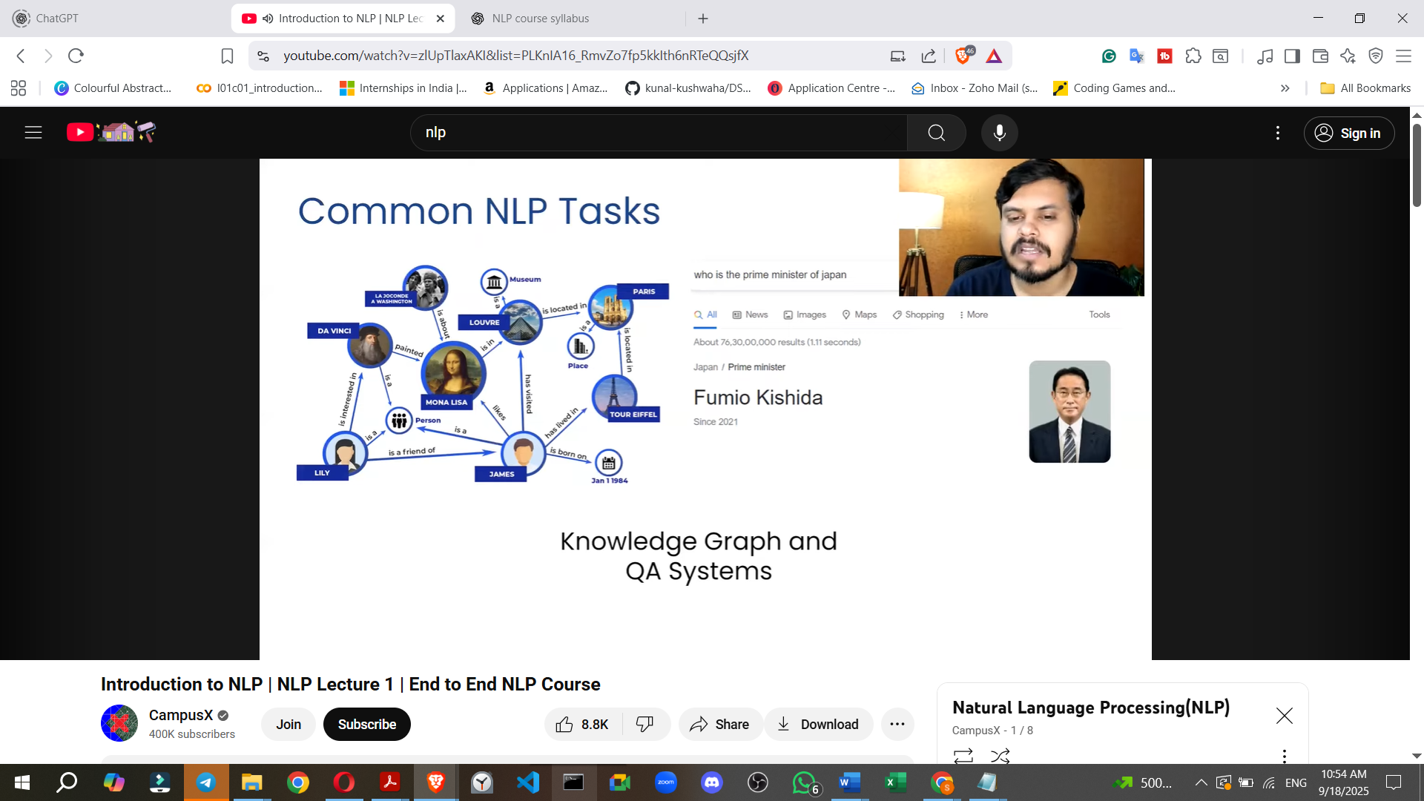

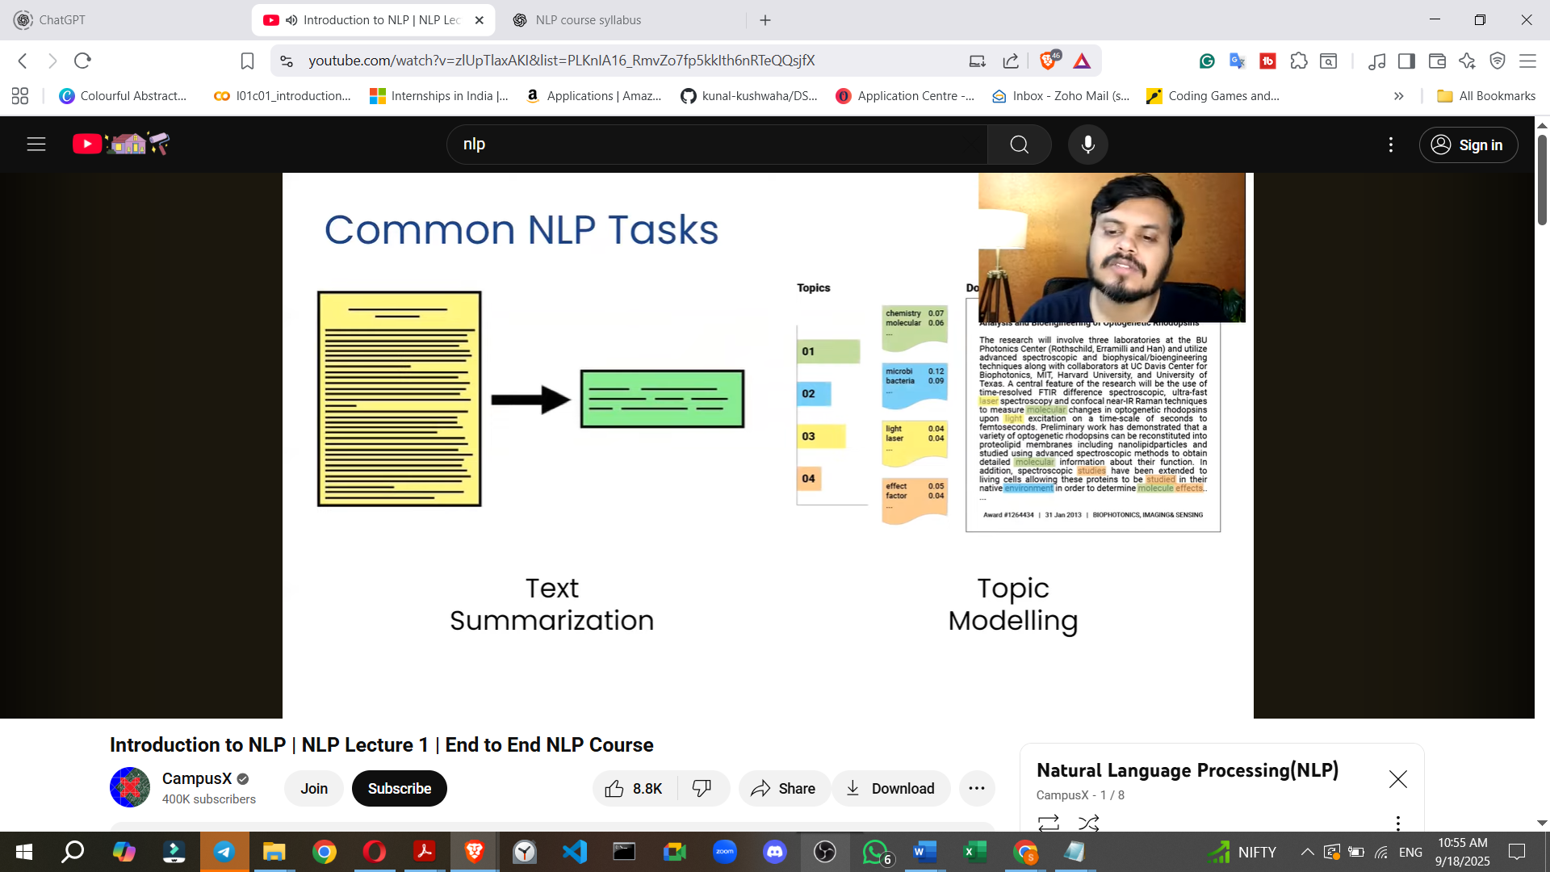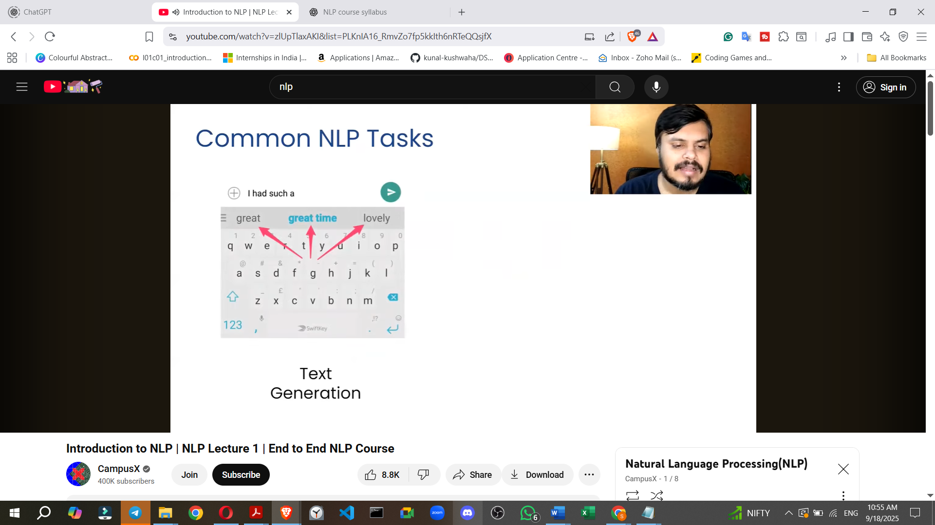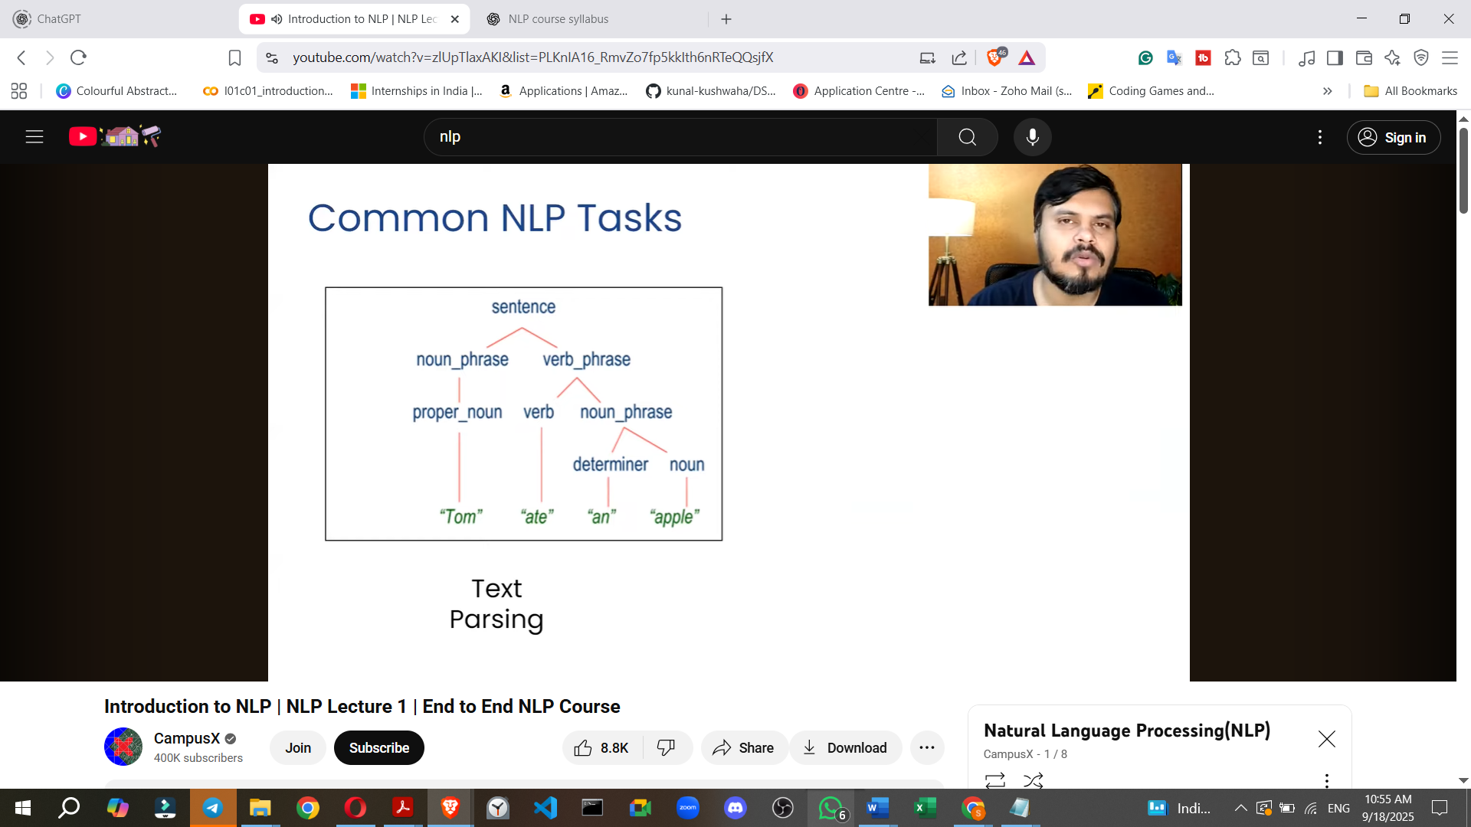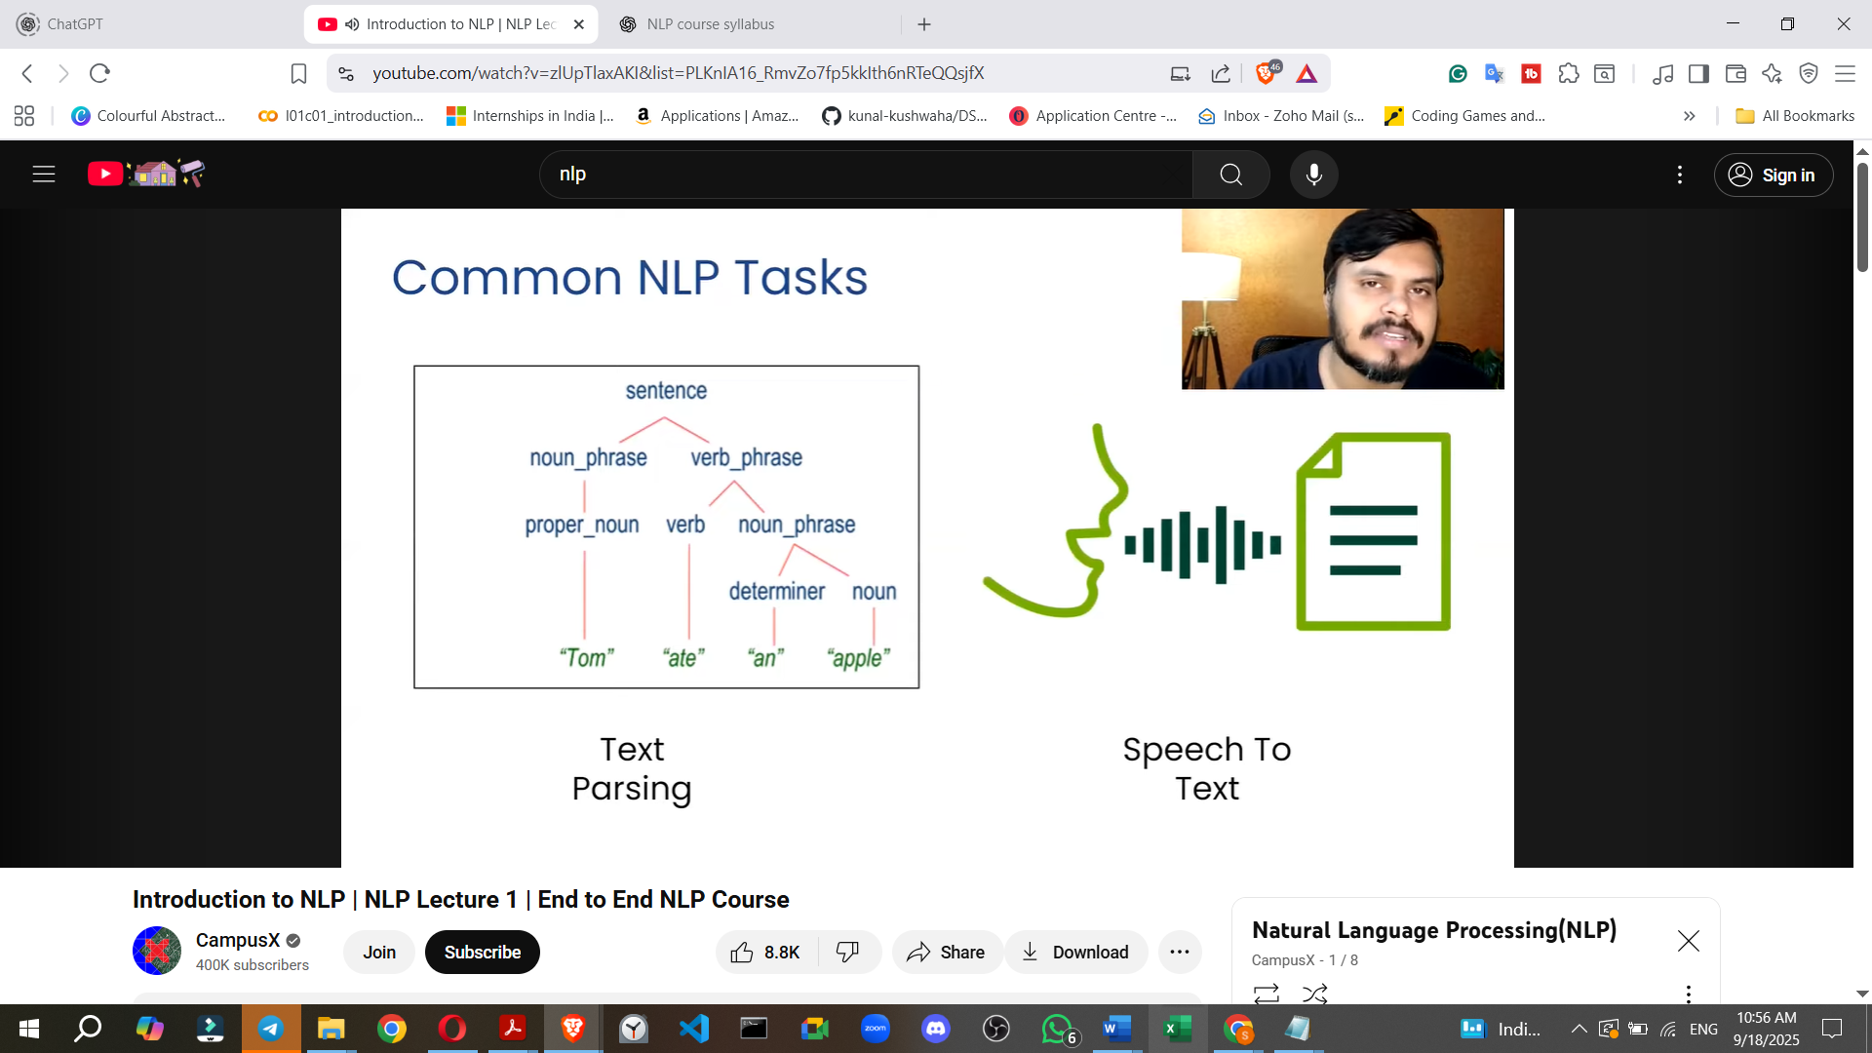

* **Text/Document Classification**: Categorising large texts into predefined categories (e.g., classifying news articles as 'sports', 'politics', 'entertainment').
* **Sentiment Analysis**: Determining the emotional tone or sentiment (e.g., positive, negative, neutral) expressed in reviews or social media posts, widely used in e-commerce and social media.
* **Information Retrieval (Entity Extraction)**: Extracting specific entities from text, such as names of persons, products, events, or dates. This is used internally by search engines.
* **Part-of-Speech (POS) Tagging**: Assigning a grammatical category (e.g., noun, verb, adjective) to each word in a text. This helps in understanding sentence structure for chatbots or question-answering systems.
* **Language Detection and Machine Translation**: Identifying the language of an input text and then translating it into another desired language (e.g., Google Translate).
* **Conversational AI (Chatbots)**: Developing systems that can engage in natural, human-like conversations, which can be text-based or speech-based (like Siri).
* **Knowledge Graphs and Question-Answering Systems**: Building structured knowledge bases by logically connecting entities from large datasets. This allows systems to answer factual questions directly and quickly (e.g., Google's ability to answer "Who is the Prime Minister of Japan?").
* **Text Summarisation**: Condensing a long text or article into a shorter, concise summary (e.g., news summary apps like InShorts that provide news in 60-word summaries).
* **Topic Modelling**: Identifying the underlying topics within a large body of text (e.g., discerning if a cricket article is about IPL or Sachin Tendulkar). This often involves machine learning algorithms like Latent Dirichlet Allocation (LDA).
* **Text Generation**: Predicting the next word or phrase in a sequence, commonly seen in keyboard auto-suggestions.
* **Spell Checking and Grammar Correction**: Identifying and suggesting corrections for spelling mistakes and grammatical errors in written text (e.g., Grammarly).
* **Text Parsing**: Breaking down a sentence into its grammatical components to help machines understand its meaning and structure. This is an important step in building chatbots.
* **Speech-to-Text**: Converting spoken audio into written text (e.g., Siri). This is often combined with text-to-speech to enable machines to converse audibly.

## **Approaches to NLP Problem Solving**

Throughout the history of NLP, three main approaches have been used to create applications:

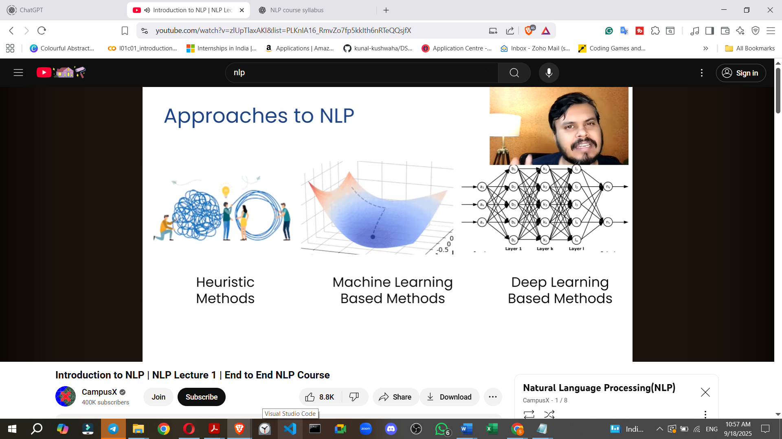

**1. Heuristic Methods (Rule-Based)**

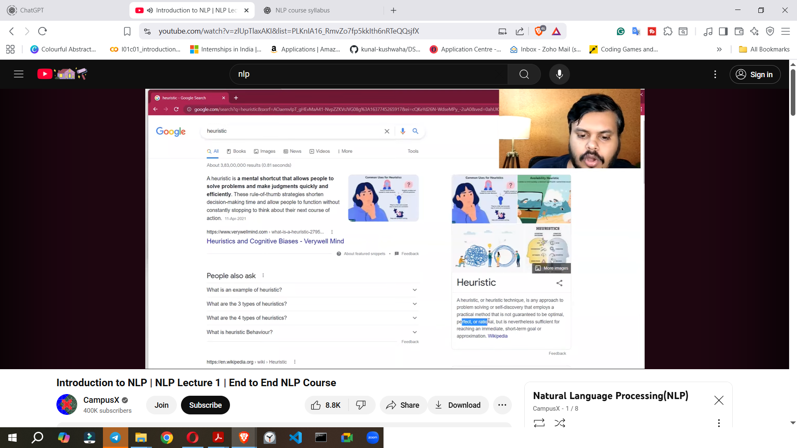

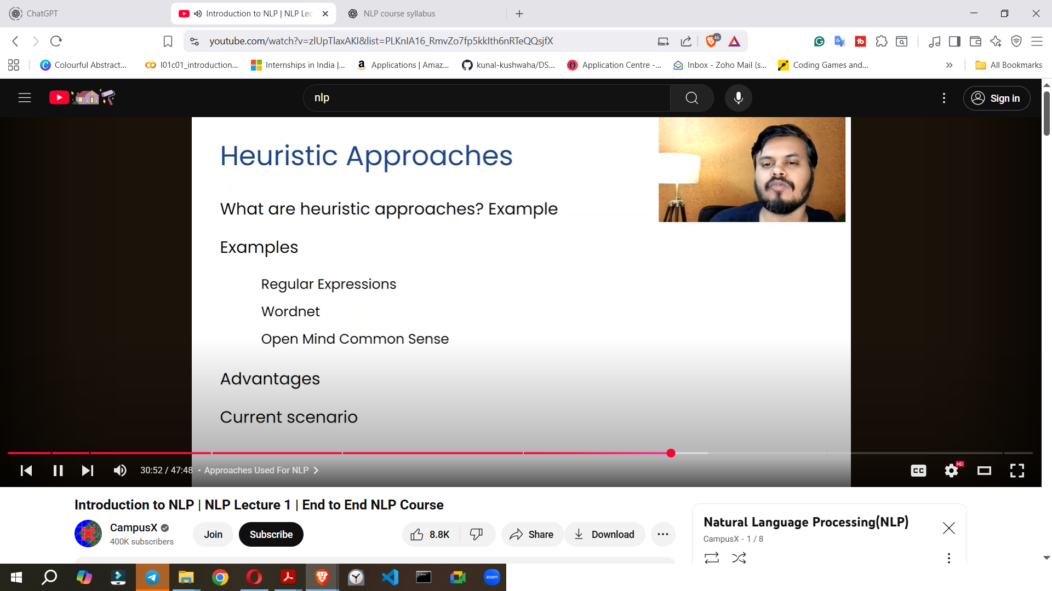

* **Period of Use**: Predominantly used from the start of NLP until around the 1990s, but still relevant today.
* **Definition**: Heuristic approaches involve employing practical, "jugaad" (improvisational) methods for problem-solving that are not guaranteed to be perfect but are sufficient for achieving immediate, short-term goals.
* **Mechanism**: NLP practitioners typically created **rule-based systems**, where rules were explicitly defined. For example, in sentiment analysis, rules might count positive and negative words.
* **Examples**:
  + **Regular Expressions (Regex)**: Used to define and match text patterns, such as removing HTML tags from a text or finding specific salutations (e.g., Mr., Dr.).
  + **WordNet**: A lexical database that stores words, their meanings, synonyms, antonyms, and various relationships with other words in an organised structure. It serves as a valuable resource for complex NLP tasks like translation.

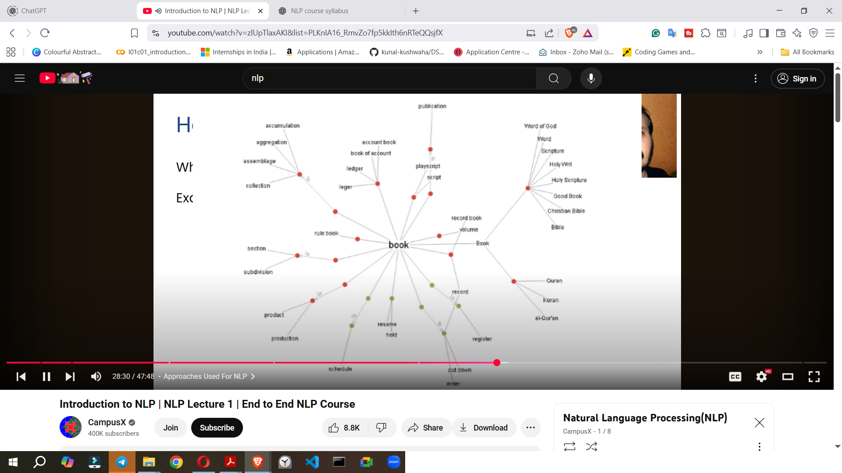

* + **Open Mind Common Sense**: An open-source, community-driven database that collects common-sense facts about the English language, creating a large repository of knowledge for NLP systems.
* **Advantages**: Heuristic methods often provide **quick and accurate answers** with a lower chance of error because the rules are human-designed. They are still used today, often in conjunction with more advanced techniques.

**2. Machine Learning (ML) Approaches**

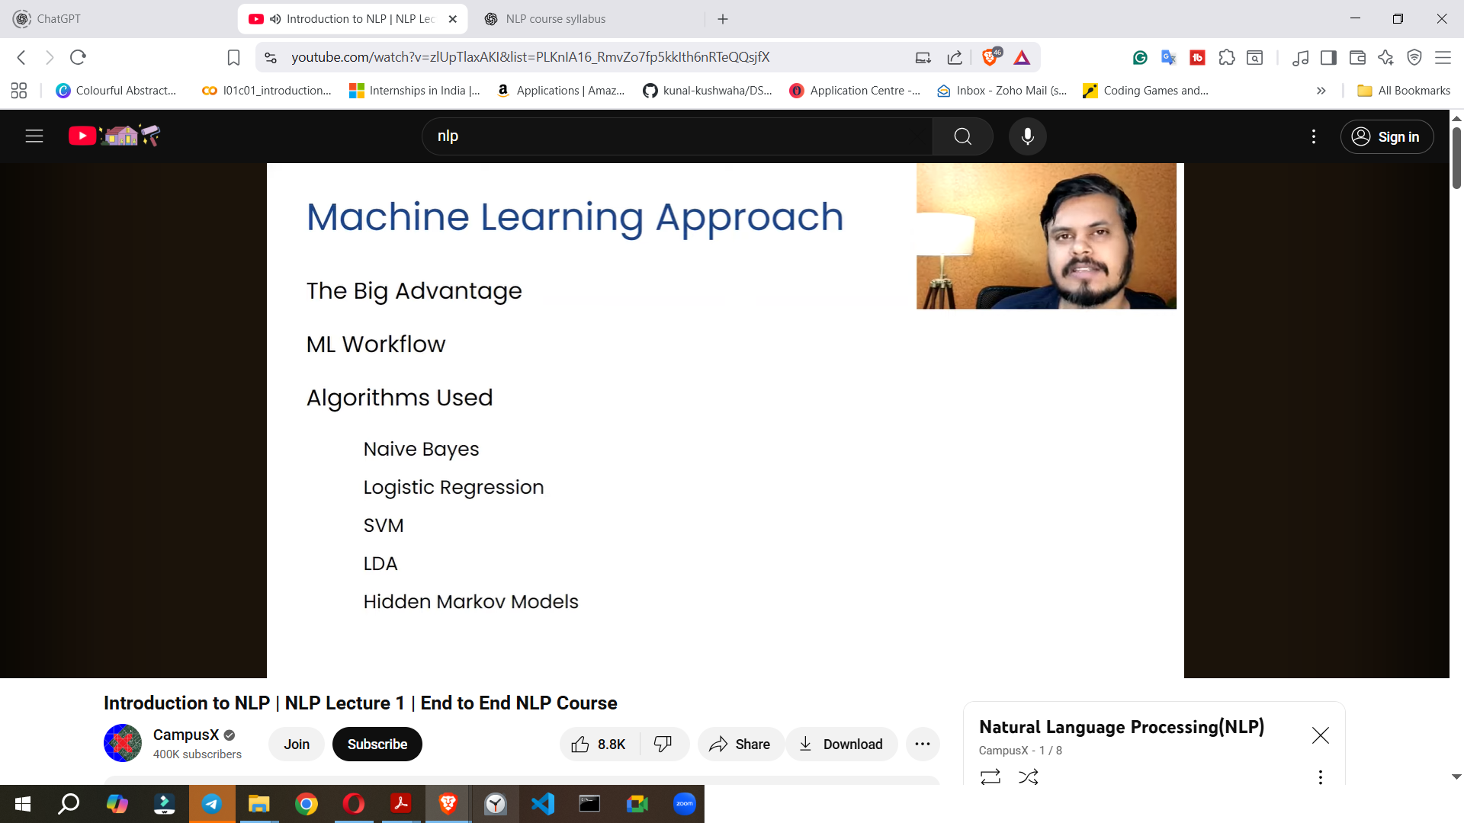

* **Period of Use**: Began around the 1990s and is still actively used.
* **Advantages over Heuristics**: ML approaches are particularly effective for **open-ended problems** where it's impractical for humans to define all possible rules. Instead, ML algorithms learn the underlying relationships between input (text data) and output by analysing data, creating rules internally rather than relying on predefined ones.
* **Mechanism**:
  + Text data is converted into numerical representations (known as **text vectorisation**).
  + These numerical representations are fed into a machine learning algorithm.
  + The algorithm's output is then evaluated.
* **Common Algorithms**:
  + **Naive Bayes**: Known for performing well with text data.
  + **Logistic Regression**: A powerful classification algorithm.
  + **Support Vector Machines (SVM)**: Another effective classification algorithm.
  + **Latent Dirichlet Allocation (LDA)**: Used for topic modelling.
  + **Hidden Markov Models (HMM)**: Can be applied to tasks like Part-of-Speech Tagging.

**3. Deep Learning (DL) Approaches**

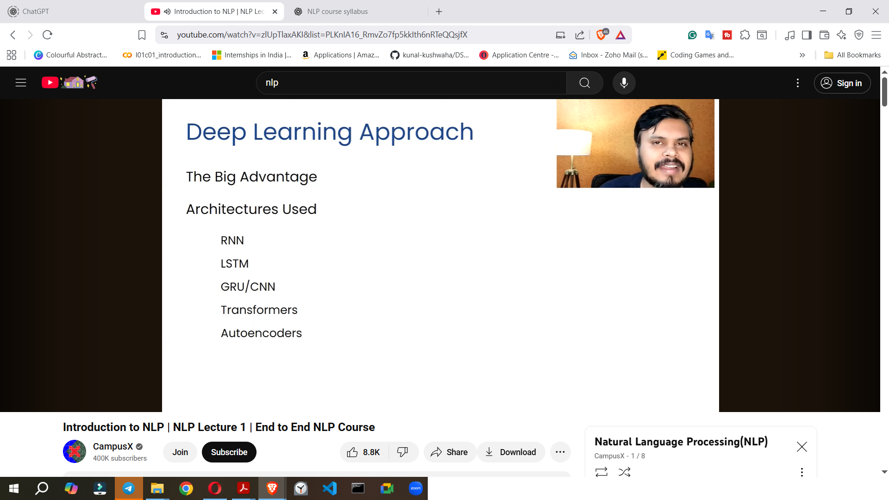

* **Period of Use**: Began around 2010 and has since revolutionised NLP.
* **Advantages over Machine Learning**:
  + **Retention of Sequential Information**: A major advantage is DL's ability to **utilise and retain the sequential information within text data** (e.g., word order in a sentence). Traditional ML algorithms often lose this crucial information when text is converted to numbers. This leads to significantly better results.
  + **Automatic Feature Generation**: Deep learning models automatically learn and generate relevant features from the data, reducing the need for manual feature engineering that is often required in traditional machine learning.
* **Common Architectures**:
  + **Recurrent Neural Networks (RNNs)**: The first DL architecture to perform well on sequential data like text. However, they struggle to retain context over very long sentences.
  + **Long Short-Term Memory (LSTMs)**: An improvement over RNNs, LSTMs excel at **retaining context over longer sequences**. They are widely used in deep learning-based NLP applications.
  + **Gated Recurrent Units (GRUs)**: Similar to LSTMs, GRUs are also frequently used, particularly for text generation.
  + **Convolutional Neural Networks (CNNs)**: Though primarily used for image classification, CNNs are also applied in some NLP tasks, such as text classification.
  + **Transformers**: Introduced around 2017, Transformers **revolutionised NLP** by enabling models to provide "attention" to specific parts of a sentence, thereby understanding context more effectively. Most **state-of-the-art NLP models today are Transformer-based** (e.g., BERT, trained by Google).
  + **Autoencoders**: These neural networks (typically with an encoder and a decoder component) are often used for tasks like machine translation.

## **Challenges in NLP**

Applying NLP is considered a difficult and challenging task due to the inherent complexities of natural language, which has evolved over millennia. Currently, only about 5% of NLP's true potential is realised due to these challenges.

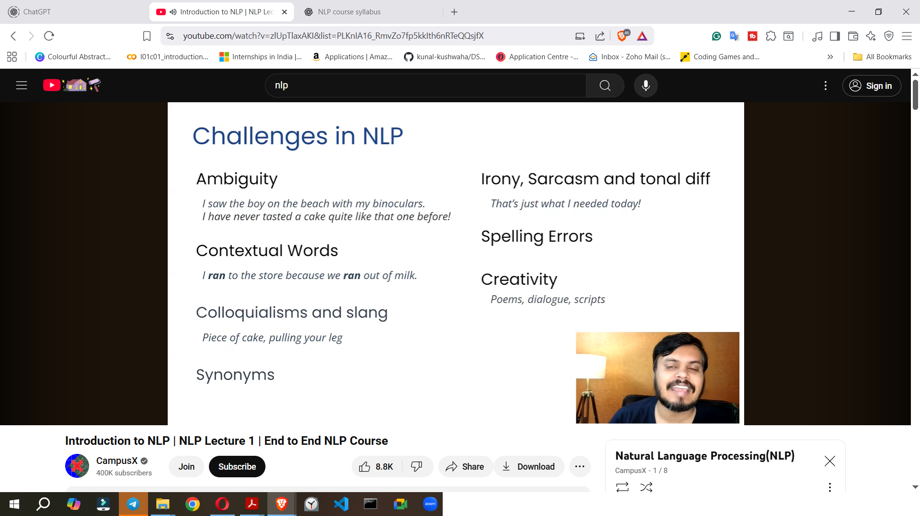

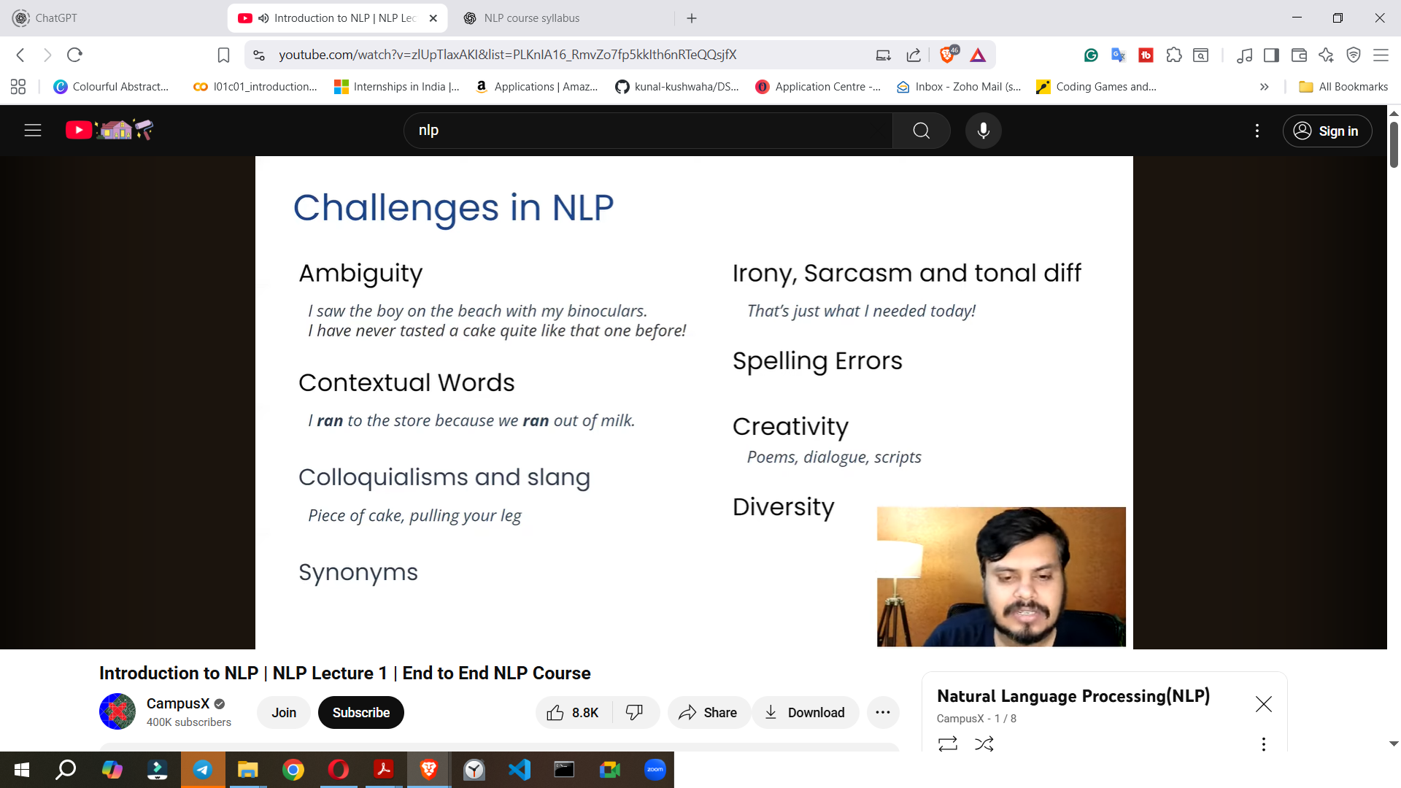

* **Ambiguity**: Natural language frequently exhibits ambiguity, where a sentence can have **multiple interpretations**. While humans can infer the correct meaning from context, machines struggle.

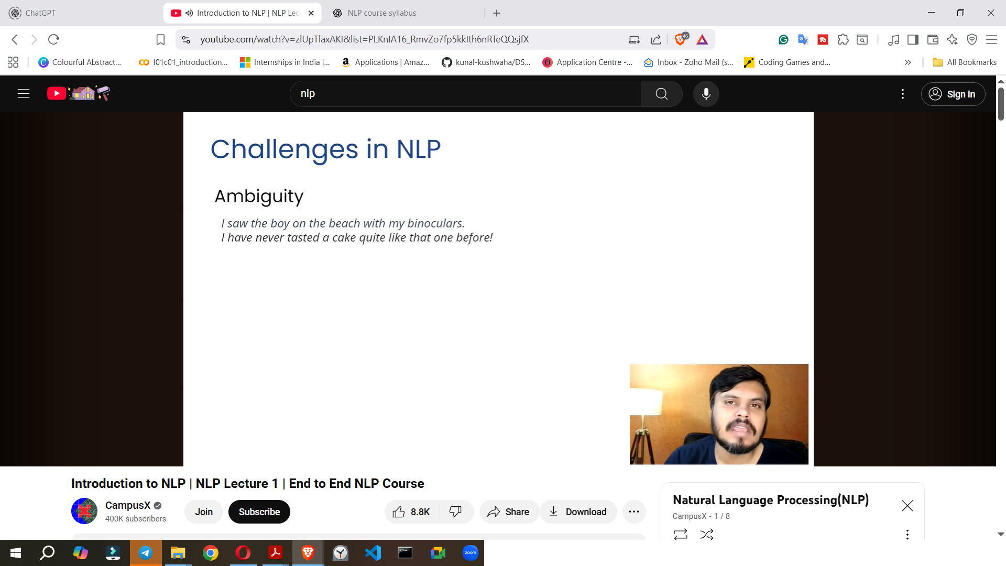

* + **Example 1**: "I saw the boy on the beach with my binoculars" could mean the boy possessed binoculars or the speaker used binoculars to see the boy.
  + **Example 2**: "I thought the cake tasted quite like that" – the true meaning (positive or negative) depends entirely on the speaker's tone, which is difficult for a machine to discern from text alone.
* **Contextual Words**: The **same word can carry different meanings** depending on the context in which it is used.
  + **Example**: In "I **ran** to the store because we **ran** out of milk," the word "ran" has distinct meanings in each instance.
* **Colloquialisms, Idioms, and Slang**: Everyday language is rich with expressions where the **literal meaning differs from the intended metaphorical meaning**.
  + **Example 1**: "That task is a **piece of cake**" means the task is easy, not literally a cake.
  + **Example 2**: "**Pulling someone's leg**" means teasing, not physically pulling their leg.
* **Synonyms and Antonyms**: The existence of numerous words with similar (synonyms) or opposite (antonyms) meanings adds complexity for machines trying to grasp precise meaning.
* **Sarcasm and Tonal Differences**: Machines find it challenging to detect sarcasm or differentiate meaning based on the **tone of voice**, which can completely alter a sentence's intent.
  + **Example**: "That's just what I needed today" can be an expression of happiness or deep frustration, depending on the tone.
* **Spelling Errors**: Humans can often infer the correct word despite a spelling mistake from the surrounding context. However, a machine might not recognise a misspelled word, making it impossible to process its meaning.
* **Creativity**: Understanding creative forms of language, such as poetry, dialogues, or scripts, is difficult because they often contain **subtext or implied meanings** that go beyond the literal words.
* **Multitude of Languages and Dialects**: There are thousands of languages globally, and it is **extremely challenging to decode the grammar and nuances of each**, especially less common dialects. For rare languages, there is often insufficient data available to train NLP models effectively.